Fine Arts Department
Pontiac Township High School
District 90
1100 East Indiana Avenue
Pontiac, Illinois 61764
(815) 844-6113
June, 2017

Dear Band Members and Parents:

Marching Band Camp is not too far away and we wanted to remind you of the schedule and needs for the week. Your attention to these items and the schedule will make us as competitive as we have ever been during the fall marching season. We have assembled all of the elements to make our show entertaining, competitive, and fun to learn. Individual responsibility for your attendance, music preparation, and disciplined work habits will make the difference in the quality of our performance All students may listen to the music for the entire show by going to the PTHS marching band website at:
www.pthsfinearts.org
CHARMS: Parents are reminded to update info in Charms.
Volunteer opportunities for parents follow on the enclosed pages and also appear in Charms on the specific date of the event. Please take a look to see where you might be able to help out. Sign up in Charms or these forms can be turned in at registration or returned to the high school or a music booster officer in advance of registration. Thank you! Also included is a medical release form to be completed and returned by registration.
The schedule for the camp is as follows:
Sunday, July 30 5:00p.m. Registration - $130 plus photo button, decal, and t-shirt orders.
Payments can be made with check, cash, or credit card. Turn in Parent volunteer & medical release forms.
6:00 p.m. NEW STUDENT PARENT MEETING IN BAND ROOM.
This meeting will acquaint parents of new students with the
band program and the opportunities for their students during
the coming school year.
6:00 – 8:30 p.m. Rehearsal for all students
July 31 – August 3 8:00-11:30 a.m. Rehearsal with a break for refreshments.
11:30-12:30 Lunch at school - all students are required to stay at school
12:30-3:30 p.m. Rehearsal
3:30-6:00 p.m. Dinner on your own
6:00-8:30 p.m. Rehearsal
Thursday Night: Parent Meeting for all parents in the auditorium, 6:15 p.m. This short meeting presented by the PTHS Music Boosters will discuss Booster activities for the year, with volunteer opportunities for parents.

Demonstration/Performance 7:00 - 7:30
For all parents and community. Invite your family and friends for this fun evening. Pizza and soda provided after the performance. Student dress for the demonstration performance is khaki shorts, band t-shirt, MTX marching shoes and black socks.
Items needed for camp:
1. Instrument and case, music, flip folder, lyre and accessories
2. MEMORIZED show music and flip folder music.
3. Shirt, Sunscreen, bug repellent, personal water cooler
4. Comfortable marching shoes and socks - absolutely no sandals or the like
5. Binder for music and drill charts with shoulder strap, coordinates, and pencil
6. Performance attire for Thursday night
7. Positive Attitude & P.R.I.D.E. (Personal Responsibility In Daily Effort)
We’re looking forward to a great marching season ahead. See you all on July 30th!

Sincerely,
Scot Schickel & Corey Brown - Band Directors

PARENTS – PTHS MUSIC BOOSTERS WELCOMES YOU!

IT’S GOING TO BE ANOTHER FUN YEAR!!!

This letter is to welcome all parents of PTHS music students to PTHS Music Boosters. The support parents have given in the past has been outstanding. We welcome many of you back and invite the parents of new students to participate in Booster activities this year. If you have not had the opportunity to be involved with Booster activities in the past, we welcome you to join us! The high school years pass by so quickly!!! Being active with Music Boosters is a great way to share the high school years with our children. It is a lot of fun and a great way to get to know the kids, parents and our excellent Music Department staff.

Our music students are very talented individuals that we should all be proud of. They have made a commitment to work many hours outside of the classroom to learn, compete and entertain the people of our community. None of this would be possible without the hard work and devotion of their instructors, Mr. Schickel, Mr. Brown, and Mr. Durbin. By being an active Booster member you have the benefit of seeing the efforts of their hard work and dedication first hand.

2017-2018 Music Booster Officers

President Candice Vilt
Vice-President Shelley Hicks
Secretary Anne Corrigan
Treasurer Tracy Bromley

IMPORTANT: On Thursday, August 3rd at 7:00 pm the band and flags will perform for the parents. AT 6:15 PM ON THE 3rd THERE WILL BE A BOOSTER ORIENTATION MEETING HELD IN THE HIGH SCHOOL AUDITORIUM. The meeting will be short, but very important, since we will be giving a heads up on what will be happening throughout the year and answering any questions that parents may have. SIGN UP SHEETS FOR VOLUNTEERS NEEDED FOR ACTIVITIES THROUGHOUT THE YEAR FOR BOTH BAND AND CHORUS WILL BE IN THE COMMONS AREA. AS ALWAYS, WE NEED YOUR HELP FOR THE SUCCESS OF THE MANY EVENTS THAT HAPPEN THROUGH THE YEAR!!

Please make every effort to attend the 6:15 pm meeting, sign up to help for at least one event, and then head to the marching field to see the results of everyone’s hard work during band camp week.

If you have any questions, please give me a call. I look forward to working with all of you during this next year.

Candice Vilt, President

BAND CAMP FOOD DONATIONS & SERVING HELP

PTHS Band 2017
Please return this form to Mr. Schickel, Mr. Brown, or a Music Booster officer at registration

Music Boosters needs help preparing and serving both lunch and refreshments, and preparing treats for lunch and refreshments for our hard working band kids. We will need 5-6 servers each day, plus we need parents to provide small food items. The lunch servers do not need to worry about preparing food because we will order in each day. What the parents do is organize the food lines, serve the food and help with clean-up after lunch. Our work schedule is approximately 9:45-10:45 for refreshments, and 11:30-12:45 for lunch each day. Please look ahead to your August calendars, see if you can help with this, and if that doesn’t work for you, please consider providing some of the treats listed below for the kids. Please give Anne Corrigan, (815-848-6767) a call if you can help in this way.

I will help serve refreshments from 9:45 to 10:45 on:

____________ Monday____________ Tuesday____________ Wednesday____________ Thursday

I will help serve lunch from 11:30 to 12:45 on:

____________ Monday____________ Tuesday____________ Wednesday____________ Thursday

I will provide:
____________ baby carrots____________ celery sticks____________ oranges____________ grapes
____________ desserts such as Rice Krispie Treats, Scotcharoos, brownies, cookies, etc.

I will provide the above food item(s) on:

____________ Monday____________ Tuesday____________ Wednesday____________ Thursday

Please label the food items “Lunch”. You may send the item to school with your student that morning or ahead of time if that is more convenient.

Name........................................................................... Cell Phone Number.......................................

Email …………………………………………………………………………….

Please return this form to Mr. Schickel, Mr. Brown, or a Music Booster officer at registration

THANK YOU FOR YOUR HELP!!

PARENT VOLUNTEER OPPORTUNITIES FOR FALL
Please sign up at Parent Night on Thursday, August 3rd
Your help is needed!!! THANK YOU!!!
See the “helping hand” needs on the Charms Calendar

TRIP CHAPERONES
- Ride bus to and from event
- Bus Supervision
-Take roll, collect parent notes, and make announcements when necessary
-Assist bus driver with safety issues (noise levels, proper seating, forward sitting,
aisles clear, etc.)
-Check for left items on bus on return (return them to band room)
- Event Supervision
-Help with student supervision (homeroom, hallways, proper behavior, respect for
property)
-Help watch for student illness, injury, uniform problems-assist when possible

FOOD!!
- Donate food requested by food chair people for the times we are traveling away from home
-bring the food to the commons area of the school prior to our departure

CANDY SALES
- Bag Candy for annual candy sale (see calendar)
- Hand out candy/collect money from students before and after school

UNIFORM FITTING
- Be present prior to performances/concerts to help students with uniform difficulties, buttons off, missing parts, etc.
- Help fit students with uniforms during band camp

UNIFORM ALTERATIONS
- Sew uniform parts to fit (hems, sleeves, etc.)
- Press hems, remove hems

FLAG SEWING
- Sew flags from pattern

PIT CREW
- Assist with moving equipment on and off field at games and competitions

INDIAN SHOWDOWN! – Saturday, September 16th
- All kinds of help will be needed all day long

VIVA LA MUSICA!
- Provide an auction item
- Help with the evening activities
- Deal black jack, etc.

Please contact a Music Booster Officer if you can help in any way.

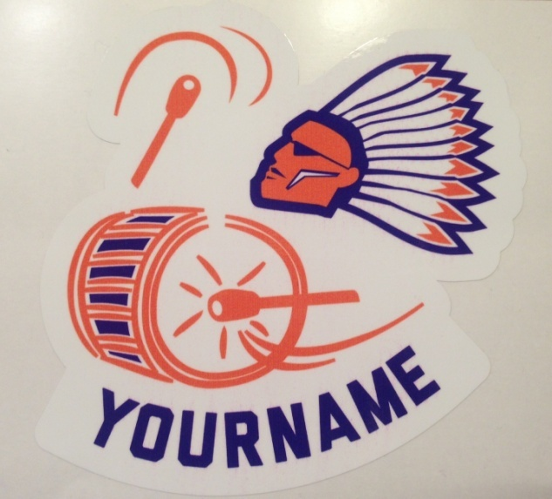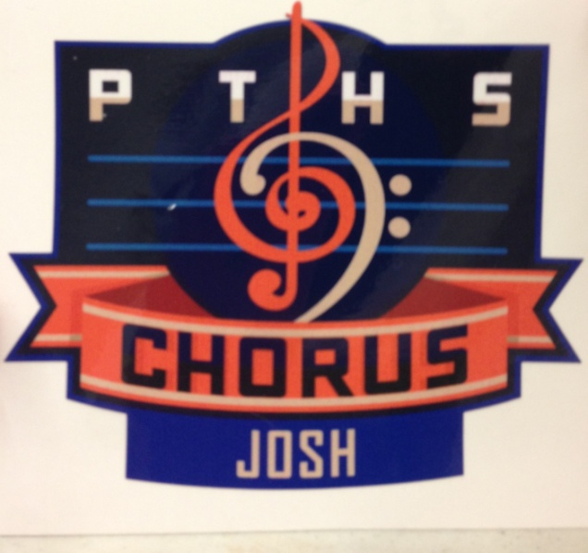
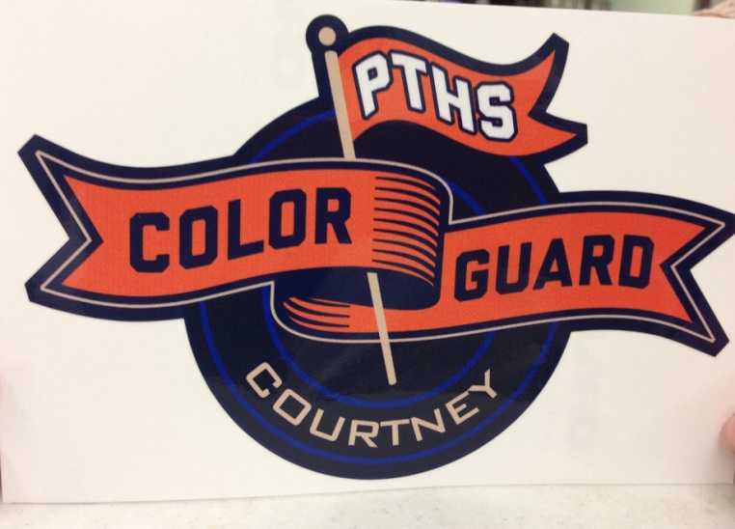

DECAL ORDER FORM

Which ones and how many? Band ______ Chorus ______ Flags ______

What name do you want on the decal? _________________________________________ (please print)
(10-12 Letters maximum works best!)

What student should we deliver these decals to? ___________________________________ (full name)

Number of decals order _______ X $6.00 each = $_________

(Turn this form in at registration)
PHOTO BUTTON ORDER

Share your Pride!! Pictures of all band and flag members ordering picture buttons will be taken at registration. These buttons may be ordered by parents at registration. Cost is $5.00 per button. Please use the form below and return at registration. If a button is not paid for, a button will not be made.

Student Name ……………………………………..…....................... # of buttons …..…...

(tear off and turn in at registration)

…………................…………………….....................................................................................................

BAND T-SHIRT ORDER FORM
(for parents, family and friends – student T-shirts are already provided)

If you would like this year’s Band T-shirt, please submit this form at registration.

Name ……………………………………………….…….............................

Quantity of each size: Small _____ Medium _____ Large _____ XLarge _____

2X Large _____ 3X Large ______

TOTAL NUMBER OF SHIRTS ORDERED: _________ @ $15.00

Which band student will deliver this to you? ………………………………......................................
(tear off and turn in at registration)

…………................……………………......................................................................................................

VISIT OUR WEB-SITE

www.pontiac.k12.il.us>departments>academics>music

FOR THE MOST CURRENT INFORMATION ON ACTIVITIES AND SCHEDULES

Pontiac Township High School
MARCHING BAND UNIFORM CLEANING GUIDE
Follow these instructions to the letter!!! DO NOT HAVE YOUR UNIFORM DRY-CLEANED. If you are on well water, have hard water, and/or you have experienced problems in laundering clothes - especially whites - please take your uniform to a reputable Laundromat for washing, possibly in Pontiac. (Do not dry-clean!)
Preparation for washing
- Fold the extended shoulders of the coat back onto the shoulder for washing.
- Put the Velcro of each individual gauntlet together so the Velcro does not catch the fabric while
washing.
Washing – USE COLD WATER!!
- Wash the coat and gauntlets in cold water, gentle cycle, with a small amount of mild
detergent. DO NOT use a liquid fabric softener or bleach.
- Wash the bib pants separately from the coat in cold water, gentle cycle, with a small amount
of mild detergent. DO NOT use a liquid fabric softener or bleach.
Drying
- Check the coat and gauntlets for bleeding or discoloration of the color into the white. If this
has occurred, DO NOT DRY THEM! Instead, use Carbona’s “Color Run Remover” or Rit Dye’s “Rit Fabric Treatment Color Remover” on the affected areas. Then rewash the garment and this generally will remove the problem.
- Dry the uniform parts on gentle or cool setting. Remove from the dryer and place on the
hanger immediately. When dried on a cool setting, uniforms will require very little touch up, if any.

PROPER CARE OF THESE UNIFORMS WILL HELP THEM LAST MANY YEARS!!

Pontiac Township High School
BLACK CONCERT DRESSES CLEANING GUIDE

**Wash on cold, gentle cycle, and hang dry**

VISIT OUR WEB-SITE

www.pontiac.k12.il.us>departments>academics>music

FOR THE MOST CURRENT INFORMATION ON ACTIVITIES AND SCHEDULES

Pontiac High School Band Performance Opportunities
Below are the wide arrays of opportunities for band students at PTHS to participate. If you have further questions, please don't hesitate to ask.
CONCERT BAND
The Pontiac High School Concert Band is the core activity of our program. Through the playing of quality literature, students are able to develop their musical skills to their potential. Concert Band begins with auditions in October for chair seating as well as one aspect of evaluation for placement in either the Symphonic or Concert Band for the following school year. This activity is required of all band members and includes three annual concerts, IHSA Organization Contest, Commencement, and other special performances as called for. We will hold our Concert Band camp for all band members in November.
MARCHING BAND
The PTHS Marching Indians strive for excellence in their fall marching band activities which include all home regular-season football games, three or four competitive marching competitions, and four local parades. All band students are required to participate in this group, which is the musical ambassador of our community all over the state. Evening rehearsals are held each Tuesday and Thursday night throughout the season.
ILMEA DISTRICT AND ALL-STATE CONCERT AND JAZZ GROUPS
Each October auditions are held in 9 separate districts throughout the state for students to participate in their district's honor bands, orchestras, and jazz bands. Students are asked to play a scale sheet, two contrasting etudes, and sight-read for this audition. Any students in grades 9-12 may participate in these auditions. Furthermore, students from each of those 9 districts are made eligible for the All-State groups by their district audition results. All-State selection, however, is limited to junior and senior students. All-State selection is the highest honor available for a high school musician in Illinois.
MADRIGAL BRASS AND RECORDERS
Each year in May auditions are held for open spots in the two small ensembles which perform with the Madrigals in their annual madrigal dinners in December. The recorders play traditional instruments and music of the Renaissance period. The brass ensemble is a quartet or quintet as abilities allow. The groups rehearse during the fall leading to the performances in December.
SOLO & ENSEMBLE CONTEST
Solo and ensemble participation at PTHS is important for all band students. The result of this participation is for all students become more proficient and better performers, which this contest is geared toward. Students are encouraged to participate in the solo contest by selecting music early (November) and preparing well.
JAZZ BAND AND JAZZ COMBO
Jazz Band and Jazz Combo members are selected each year for membership in this aspect of the program. These groups rehearse twice a week, usually beginning in November, and perform periodically throughout the second semester at contests, concerts, and community functions.
PEP BAND
This organization performs at the boys' home basketball games. All band students perform in this activity for our school. The group provides much spirit and atmosphere for our basketball team. Student conductors are used in the performances.

HONOR GROUPS
Periodically throughout the year, opportunities come available for students to participate in select groups at universities throughout the state. In most instances, students are selected from names submitted to the university by the band director. If you are interested in this type of activity, make it your desire known to me. We encourage participation only if our own performance schedule at PTHS allows. Most involve some type of audition upon arrival at the festival. Most of these opportunities carries a fee, possibly an overnight stay, and most generally transportation to the event that you would be responsible for. The following is a list of some of the groups that we have had students participate in the past, and their approximate dates.

Youth Symphony - Area youth symphonies are available by audition for the
finest wind musicians. Usually the group rehearses one night per week.
This opportunity involves a commitment to provide transportation on a
regular basis. There are symphonies in Chicago, Peoria, and Bloomington.
Inquire if interested.
Bradley Honor Band Mid-November & Late April
2 evenings, no overnight Bradley University, Peoria
Horns, Clarinets, & Trombones - in choirs with own instrument family
Western Illinois University All-Star Band Late February
2 nights overnight Western Illinois University, Macomb

TRAVEL OPPORTUNITIES FOR BAND STUDENTS

SPRING MUSIC DEPARTMENT TRIP
Bi-annual trips occurring Mid-March during Spring Break, involves some performance, some fun and 1-4 nights overnight. Costs will be announced at beginning of year and can be offset by fundraising during the year. In the spring of 2019 we will be taking our next trip to Disney World. Money raised during this year’s citrus/candy sales and Car Raffle will apply to your trip in the future. Down payments indicating interest in the trip are due at the beginning of the school year.

2017-18 TRIP MEDICAL RELEASE FORM

Student Name ______________________________________________________________________________
Parent/Guardian Name ______________________________________________________________________
Address ___________________________________________________________________________________
Persons to contact in case of emergency:
___________________________________________ Home Phone: ___________________________________
Address: ______________________________ Work/Cell Phone: _____________________________________
___________________________________________ Home Phone: ___________________________________
Address: ______________________________ Work/Cell Phone: _____________________________________
If transportation is required due to illness or injury, I agree that the student may be transported by private automobile or ambulance. Yes _____ No _____

If in the judgment of the school authorities a physician is needed, it is my desire that the school contact:
Dr. ____________________________________________ Phone: __________________________________
Student is on the following medication(s): ______________________________________________________
In case of emergency, a physician should be aware of the following conditions: _________________________
________________________________________________________________________________________

____________________________________________ (Parent) agrees to release and hold harmless Pontiac High School District 90 from any and against any and all liability, loss, damage, claims, or actions for bodily injury and/or property damage, in accordance with current state and federal law arising out of participation in any music department trip.

In case transportation to a hospital appears to be required, I give the school officials permission to transport the student to the nearest hospital.

Student Signature ______________________________________ Cell#: _____________________________
Parent Signature _______________________________________ Cell#: _____________________________
Date _______________________
__________________________________________________________________________________________

PARENT PERMISSION SLIP

My son/daughter has my permission to participate in the activities and trips of the music department for the 2017-2018 school year.

Parent/Guardian Signature ___________________________________________ Date _________________
Student will not be able to participate if the medical release form and parent permission slip is not returned.

